SBA Trading Pty Ltd T/A
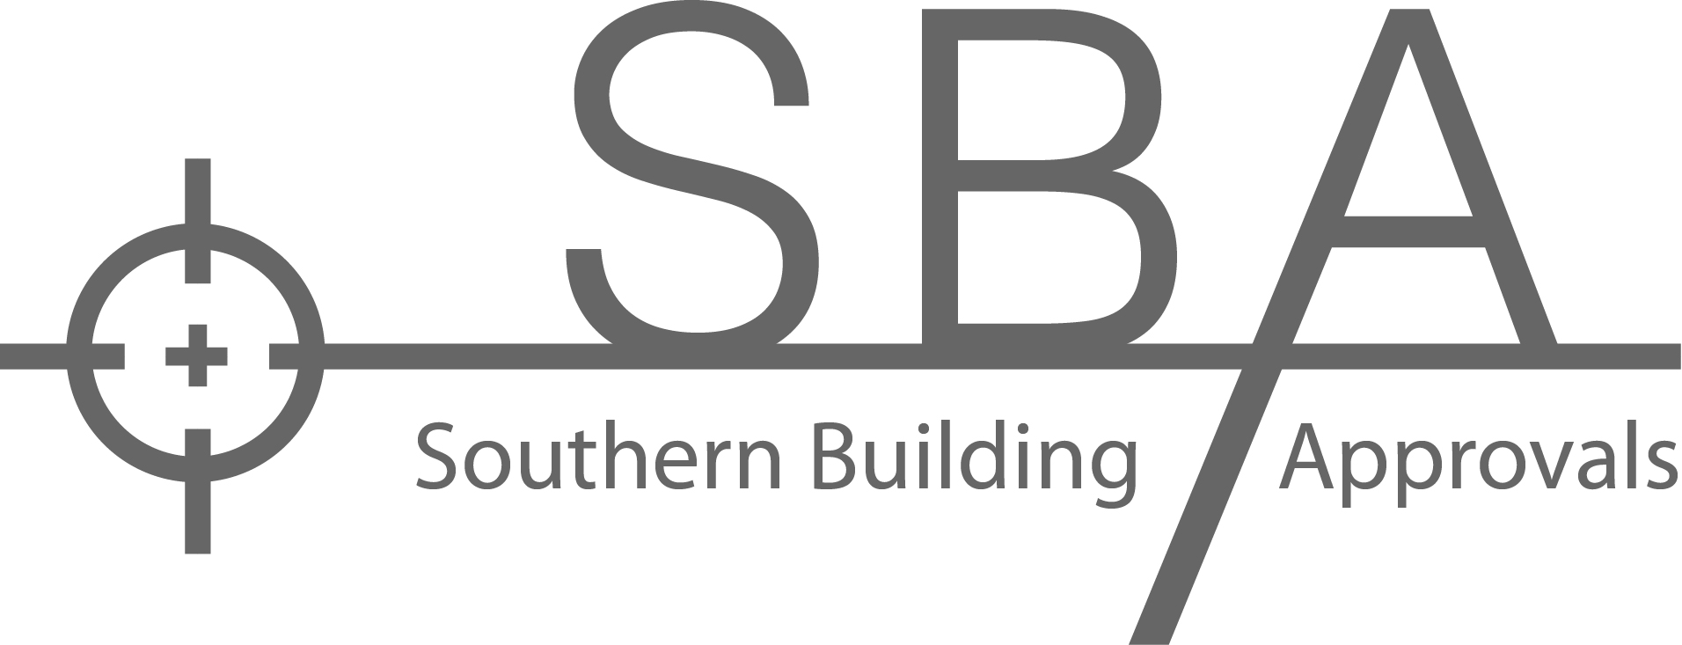
Southern Building Approvals
146 Currells Road
Port Campbell Vic 3269
P: 0488543202
E: angus@southernbuildingapprovals.com.au

STATEMENT OF COMPLIANCE WITH BUILDING PERMIT

Building Permit Number: …………………………………………………………………………………………………………………

Project Address: …………………………………………………………………………………………………………………………...

This statement is provided to the Relevant Building Surveyor: Angus Gordon BS-L 39878 advising the following items have been installed and/or constructed in accordance with the Building Permit, the documentation forming part of that Building Permit, NCC BCA Vol 2 and relevant Australian Standards.

ENERGEY EFFICIENCY:
All slab, wall, floor and ceiling insulation, windows, glazing and the sealing of the building (where applicable) have been completed and/or installed in accordance with the energy report and endorsed plans forming part of the Building Permit documentation.

House Energy Rating Report Number: ………………………………………………………………………… Date…………………

WET AREAS:
The following product has been installed in the bathroom/shower/laundry/WC in accordance with the manufacturer’s installation requirements applicable for waterproofing and water resistance and as per AS 3740-2010:

Product Name: …………………………………………………………………………………………………………………………….
Complying with AS/NZ 4858-2004
Note: A copy of any installation certificates are required to be provided.

BALCONIES:
The following waterproofing product has been installed to the external balcony(s) in accordance with the manufacturer’s installation requirements.

Product Name: ………………………………………………………………………………………………………………………………
Complying with AS 4654.1 & .2-2012
Note: A copy of any installation certificate is required to be provided.

LIGHTING:
All lights and globes have been installed in accordance with the NCC BCA Part 3.12.5.5 in having a maximum of 5W/m² (dwelling), 4W/m² (balcony/verandah), 3W/m² (garage/out building) and lighting around the perimeter of the building/s are controlled by daylight sensors.

Reflecting Ceiling Plan Drawing Number: ……………………………………………………………………… Date………………….

WINDOWS & GLAZING (including mirrors, shower screens and balustrades):
All windows and glazing have been constructed and installed in the appropriate locations in accordance with AS 1288-2006, AS 2047-1999, and the endorsed drawings.

Note: A copy of the installation and glazing certificates are required to be provided and must include details of what windows and glazing it certifies and compliance with the requirements of the energy rating and BAL level.

BUSHFIRE CONSTRUCTION (as applicable):

The dwelling and associated outbuildings have been constructed to a Bushfire Attack Level of BAL: ……………………...…
In accordance with AS 3959-2009 and in accordance with the endorsed drawings.

VENTILATION OF WETAREAS:
Exhaust fans vented in accordance with NCC BCA Part 10.8.2, and screened for BAL compliance where applicable

Vented to outside air………………………………………………….

ROOF VENILATION:
Roof been ventilated in accordance with NCC 2022 Part 10.8.3

How has roof been ventilated:………………………………………………………………………………………………………….

STAIRS:
The following product has been installed to stairs in accordance with the manufacturer’s installation requirements applicable for slip resistance with a rating of P3 for internal, P4 for external.

Product name:…………………………………………………………………………………………………………………………….

Owner/ Builders Name & Reg No: …...………………………………………………………………………………………………….

Signature ……………………………………………………………………………….………………... Date ………………...……….

